**How to use the Handheld Music Stand for Singers in Choirs**

*\*\* Note: the Music Stand was designed for use with ring-binder folders, holding sheets of music with punched holes, as shown in the photographs. It does not work quite so well with scores, especially thick ones \*\**

We humans, with our opposable thumbs and strong fingers, are very used to gripping things tightly to keep them steady. But the Music Stand was designed to *lessen* tension and strain in the hands and fingers as much as possible. When it is supporting a folder of music, the Music Stand should rest in the hand in a comfortable and balanced way: there should be no need to grip it or to maintain any tension in the hand, or to brace the knuckles against the “spine” as it curves down over the back of the hand - it is more comfortable to simply support the Music Stand in a relaxed way. It might seem natural at first to grip it, but this would create tension and soon become uncomfortable.

**How to hold the Music Stand**

When you first use the Music Stand, open your music folder to roughly the centre, as if you are halfway through a performance (see diagram on page 3, image 1), and place it so that the folder's covers rest in the slots at the bottom of the Music Stand.

* Hold the Music Stand as shown in first photo below. It is best to try to keep your hand approximately *in line with* your forearm – try not to bend your wrist:



***hold***

***it***

***like***

***this:***

***not***

***like***

***this:***

* 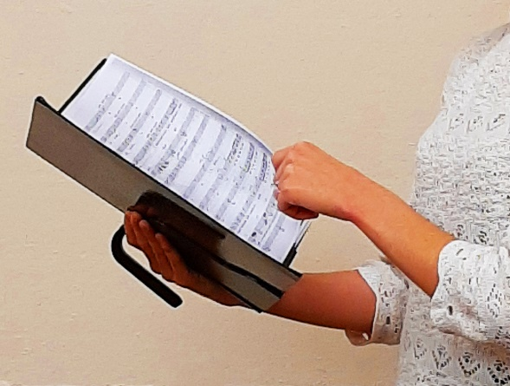The Music Stand should be held at an angle between upright and flat (see photo, right) so that it is mostly *friction* between the hand and the back of the Music Stand that holds it in place, preventing it from sliding downwards. Even though the “spine” curves over the top of the hand, most of the weight should be supported by this friction, and very little should be supported by the curved “spine” pressing down on the top edge of the hand.
* Some people like to rest the bottom edge of one of the covers of their music folder on their forearm, to provide greater support and stability – that’s fine if it works for you.
* You might even find it more comfortable to hold it with the “spine” *between* the first and second finger (see photo, right).
* Hands come in many shapes, or at least many sizes, so do please *experiment* until you find the optimum way to align your hand as it supports the Music Stand. But do allow it to just rest in the hand - resist any temptation to grip it or brace your fingers against it, and remember not to use the “spine” as a handle.
* Also, experiment by trying it alternately in the right and in the left hand: you may be surprised to find that it is more comfortable in one hand rather than in the other.

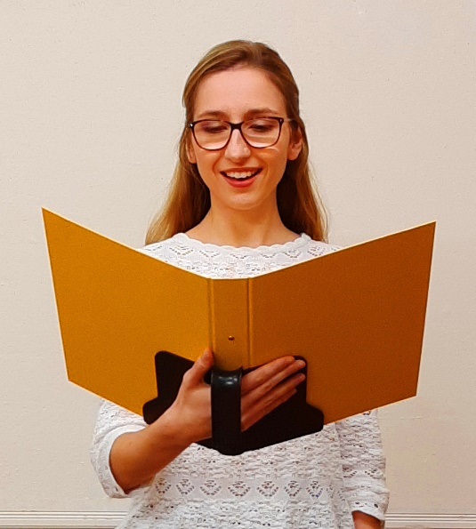

* You may find that it is most comfortable when ***all*** the fingers at the back of the Music Stand rest against it, or when ***some*** of the fingers rest against the Music Stand and the remaining ones rest against the covers of the music folder (see photo, right). That’s fine, do whatever is most comfortable.
* After you’ve tried holding your folder WITH the Music Stand, try holding your folder WITHOUT it for a few minutes, to fully appreciate how much more stable your folder is when it’s supported by the Music Stand, and how much energy you are wasting in balancing a floppy folder on your fingers.
* If the weight of the folder plus the Music Stand is an issue, you could choose not to use "polypockets" to enclose your sheets of music - there are some more suggestions about how to make your folder lighter in the FAQ section of the website (see page 3).
* Singers who do not have the Music Stand tend to allow their folder to rest in their laps when they are not referring to it. Because it is so easy to comfortably hold the Music Stand supporting a music folder, it can be tempting to hold it up in front of you all the time. But I suggest you do not do this: instead, allow it to rest in your lap when you are not referring to it. This will result in even less tiredness in the hands and fingers.

**Balance**

When there are many more sheets of music on the right side of the folder (when you are near the *beginning* of a performance) or many more sheets of music on the left side (when you are near the *end*), then the Music Stand can become unbalanced, weighing down a little on the right side (image 2, next page) or on the left side. This slight imbalance can be lessened or completely overcome by sliding the whole of the music folder to the left (when you are near the *beginning*) or sliding it to the right (when you are near the *end*). This shifts the centre of gravity of the folder and makes it feel more balanced. (images 3 and 4 below):

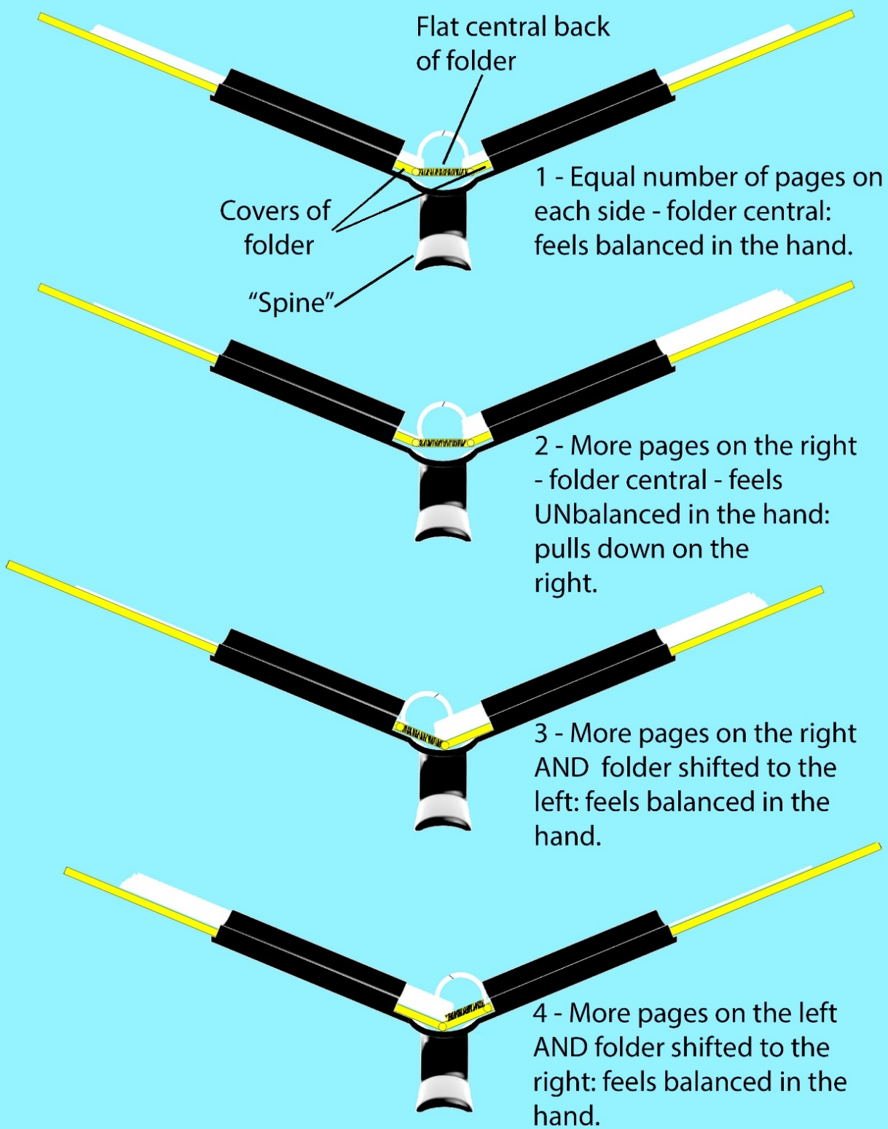

*The Music Stand viewed from below, showing the folder with*

*the pages distributed over the 2 sides in various ways.*

There is more information at [**www.handheldmusicstand.co.uk**](http://www.handheldmusicstand.co.uk)

Or email **marcuswest@btinternet.com**

** If using the Music Stand exacerbates an existing condition, or causes a new one or pain

or discomfort, then discontinue use and consult a medical professional. **